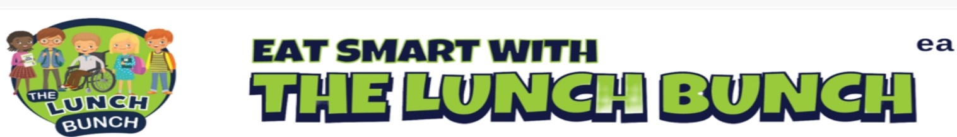

Week | Monday | Tuesday | Wednesday | Thursday | Friday
WEEK 1  18 Sept  16 Oct  13 Nov  11 Dec | Spaghetti Bolognaise or  Crispy Cod Fishcake with Tomato Ketchup  Baton Carrots & Baked Beans  Mashed Potato, Salad  Homemade Ginger Biscuit & Custard | Classic Margherita Pizza or  Italian Chicken & Tomato Pasta Bake & Garlic Bread  Garden Peas & Coleslaw  Chipped Potato, Mashed Potato  Strawberry Jelly, Ice Cream & Fruit | Lunch Bunch Chicken Curry & Naan Bread or  Chicken Panini & Coleslaw  Steamed Broccoli & Sweetcorn, Oven Roasted Potato Wedges, Rice  Banana Yoghurt Pot | Roast Chicken, Stuffing & Rich Gravy or Beef Olive  Baton Carrots & Savoy Cabbage  Mashed Potato  Chocolate Sponge & Custard | Hot Dog or Chicken Wrap & Sweet Chilli Salsa  Garden Peas & Spaghetti Hoops, Chipped Potato, Mashed Potato  Fresh Fruit & Yoghurt
WEEK 2  28 Aug  25 Sept  23 Oct  20 Nov  18 Dec | Chicken Nuggets or  Homemade Lasagne  Steamed Broccoli & Garden Peas  Chipped Potato, Pasta  Ice Cream, Chocolate Sauce & Sliced Pears | Spaghetti Bolognaise Or  BBQ Chicken Pizza  Sweetcorn & Baked Beans  Diced Potatoes, Mashed Potatoes, Salad  Fruit & Rice Pudding | Lunch Bunch Chicken Curry & Naan Bread or  Golden Crumbed Fish Fingers  Garden Peas  Rice, Salad, Mashed Potato  Rice Krispie Square & Fruit | Roast Turkey, Stuffing & Rich Gravy or Salmon Fishcake  Cauliflower & Baton Carrots  Mashed Potato  Fruit Muffin | Steak Burger & Tomato Ketchup or Chicken Crumble  Sweetcorn & Salad  Chipped Potato, Pasta  Flakemeal Biscuit & Fruit
WEEK 3  04 Sept  02 Oct  30 Oct  27 Nov | Golden Crumbed Fish Fingers or  Mighty Mac ‘n’ Cheese with Garlic Bread Slice  Baked Beans & Broccoli & Coleslaw  Mashed Potatoes  Artic Roll with Peaches | Beef Meatballs with Italian Tomato & Basil Sauce or  Margherita Pizza  Garden Peas & Salad  Oven Baked Potato Wedges, Pasta  Shortbread, Custard & Fruit | Lunch Bunch Chicken Curry & Naan Bread or  Bacon Slice  Mini Corn on the Cob  Steamed Rice, Chipped Potatoes  Strawberry Jelly & Fruit | Roast Chicken, Stuffing & Rich Gravy or  Mexican Chilli with Nachos  Baton Carrots & Tossed Salad  Mashed Potato  Jam & Coconut Sponge & Custard | Tasty Pork Sausages with Tomato Ketchup/ Gravy or  Chicken Panini & Coleslaw  Sweetcorn & Spaghetti Hoops  Chipped Potatoes, Mashed Potato, Salad  Melon Wedge
WEEK 4  11 Sept  09 Oct  06 Nov  04 Dec | Beef Bolognaise with Garlic Bread Or Stuffed Bacon Roll/Bacon Slice  Garden Peas & Cabbage  Oven Baked Potato Wedges, Spaghetti  Chocolate Cake & Custard | Golden Crumbed Fish Fingers or  Tex-Mex Enchilada  Mini Corn on the Cob & Spaghetti Hoops & Coleslaw  Chipped Potatoes, Pasta  Jelly & Mandarin Oranges | Lunch Bunch Chicken Curry & Naan Bread or  Steak Burger & Gravy  Green Beans & Sweetcorn  Mashed Potato, Rice  Cornflake Biscuit & Custard | Roast of the Day, Stuffing & Rich Gravy or  Stuffed Chicken with Cauliflower Cheese & Baton Carrots Mashed Potato  Ice Cream Slider & Fruit | Oven Baked Chicken Nuggets or  Admiral’s Ocean Pie  Garden Peas & Baked Beans  Chipped Potatoes, Jacket Potato, Salad  Homemade Ginger Biscuit & Fruit

