Saint Michael’s  Primary School | 

Notes for May 2023

Diary Dates:
Wednesday 26th April School closed- Industrial Action
Thursday 27th April County Final, Ballymacnabb @10am
Monday 1st May School Closed- Bank Holiday
Monday 8th May School Closed- Bank Holiday
Saturday 20th May First Holy Communion @11am in St Michael’s Church
Thursday 25th May P7 Pupil/Parent Transition Workshop @3pm
Monday 29th May School Closed- Bank Holiday
Afterschool clubs
Wednesdays Woodcraft Club for P6, 3-4pm x5 weeks, starting 3rd May
Thursdays GAA Club for all boys/girls from P5-7, 3-4pm, finishes 11th May
Thursdays Cookery Club for P5, 3-4 pm, x5 weeks starting 27th April
P1/2 After School Club (Mon-Thurs) 2-3pm
£16 due for the month of May.
County Final
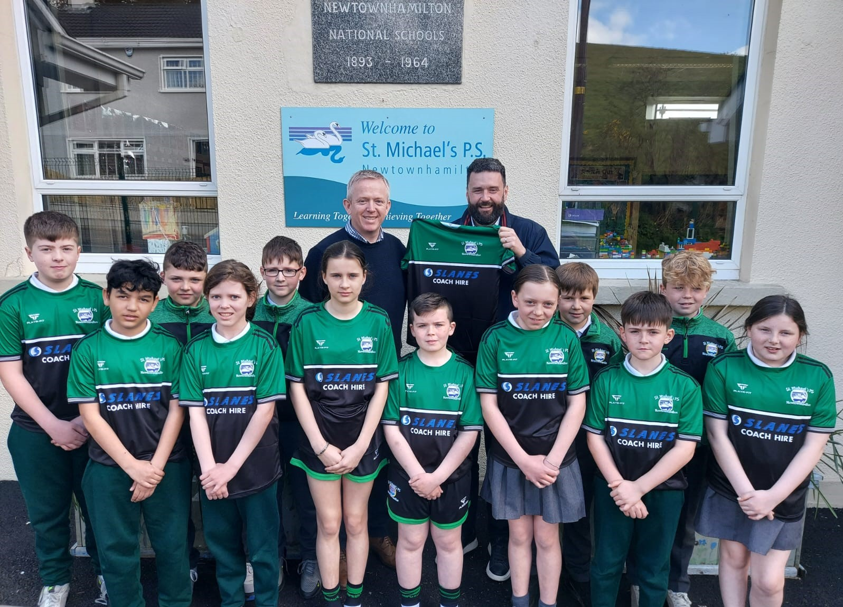
Our school football team are preparing for our biggest game in years- Small School’s County Final, Malachy Mc Geeney Cup, which will be played on Thursday 27th April at 10am in Ballymacnabb GFC. Classes P5, P6 and P7 will all be brought to the game by bus from school. Parents are welcome to join us at the grounds.
We have also been invited to play in the Gary Toner Blitz, in Belleeks on 19th May, so lots of football for everyone.
School football strip
A huge thank you to Paul from Slanes Coaches who have sponsored our new strip which looks fab. This is an investment that our school will benefit from for years to come.
Dinner Money
Please ensure dinner money is paid on Mondays for the week ahead, or at the latest on the day dinner is consumed.
Assessment Week

Computer based assessments in Literacy and Numeracy for pupils in P3-7 will take place during the week of 15th May. Please ensure your child is not missing any day unnecessarily.

Big Spring Clean Up
During the week of 8th May we will undertake a clean-up within the grounds of the school, around the Men’s Shed, Rural Hall and St Michael’s Church.

Relax Kids
We are delighted to have Joanne Callan back with us on Wednesday afternoons for 5 weeks. Each class will have a half hour therapy session.
Sacraments
Congratulations to our P4 pupils who received the Sacrament of Reconciliation on Tuesday 19th April and to our P7 pupils who were confirmed by Archbishop Eamon Martin on 21st April. Special thanks to our staff who prepared the children and to our Chaplin Canon Toner.
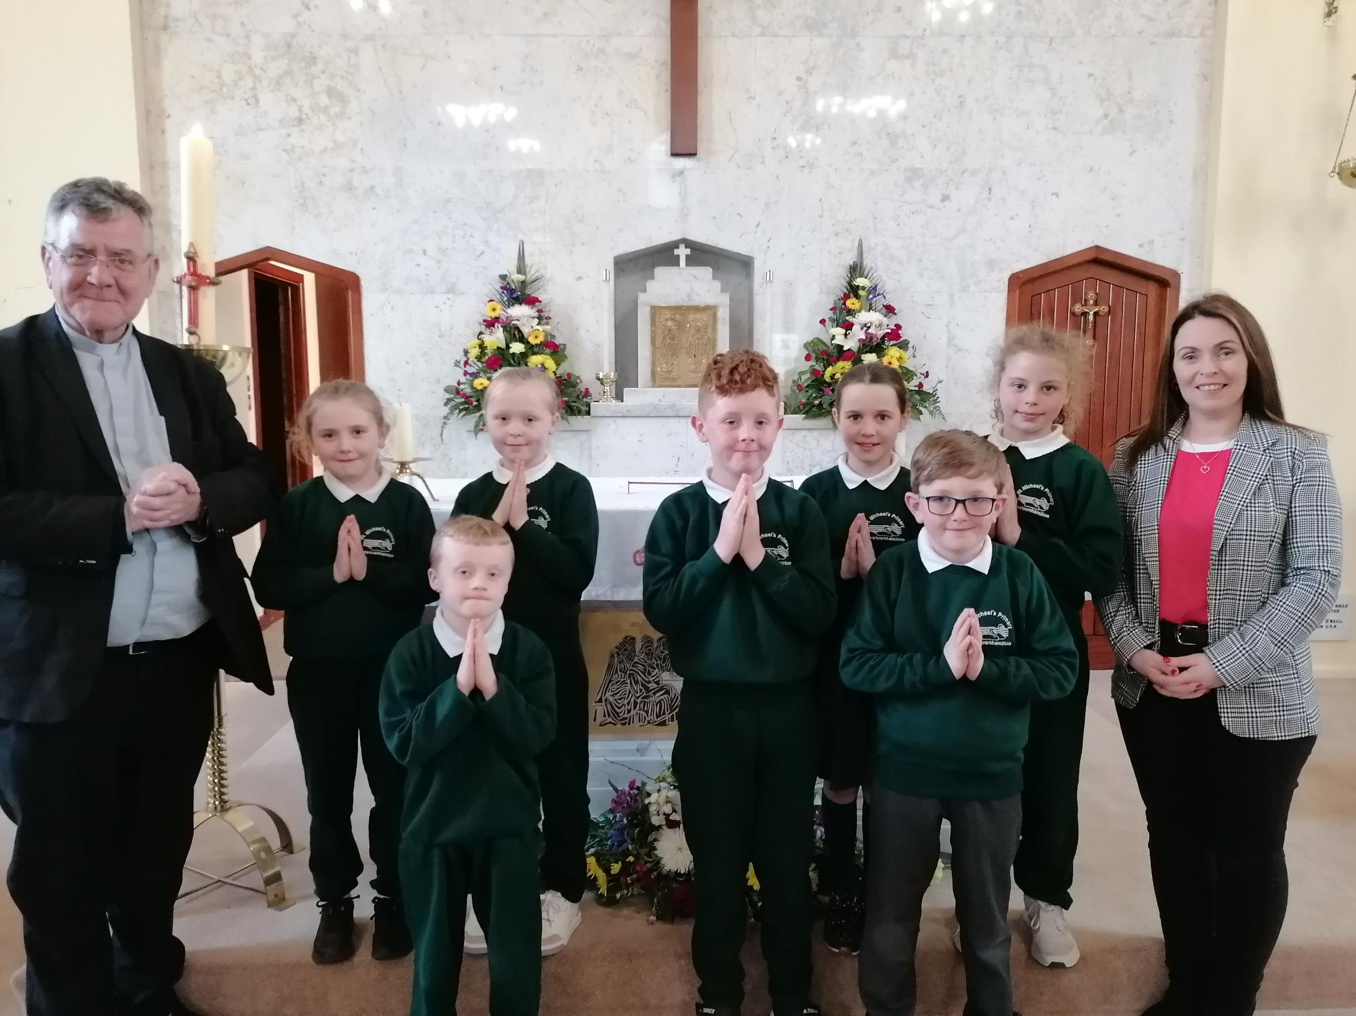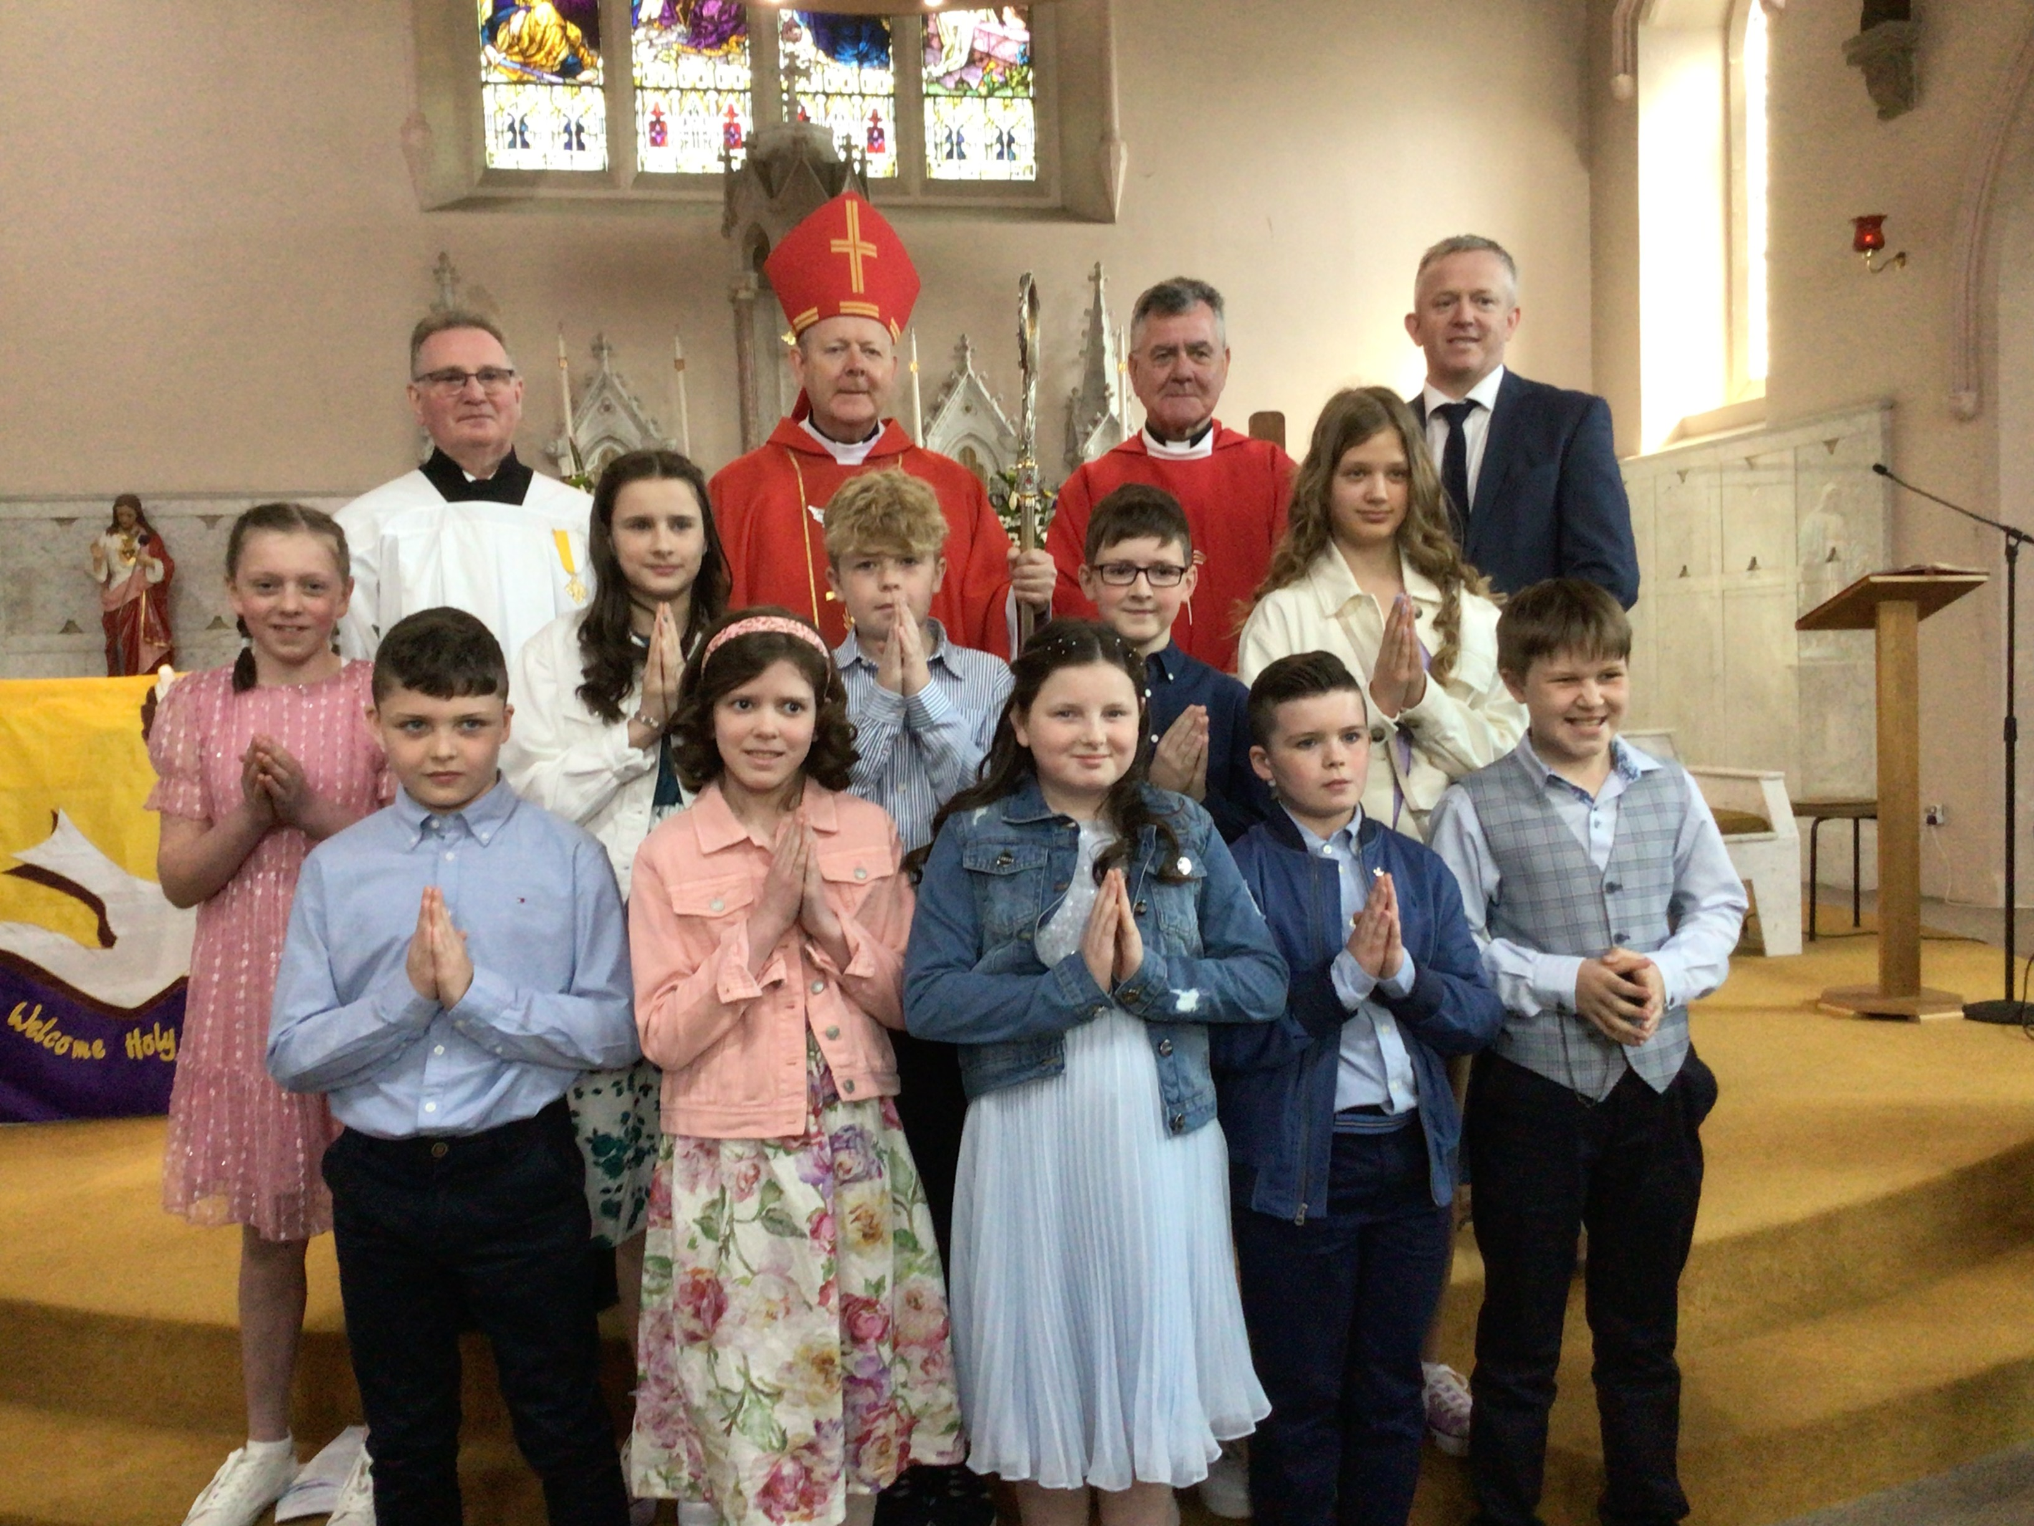
Primary 7 Leavers
Our overnight trip is on 6th June- please have balance paid by 5th May. P7’s will finish school on 20th June- on this day they will perform their Leaver’s Assembly in school at 2pm, parents are encouraged to attend.
Collecting pupils from school
Can we please remind parents that if someone other than immediate family/childminder is collecting your child you MUST INFORM SCHOOL. We will not release your child unless you have given us permission to do so.

School Holidays this term
Mon 1st May Bank Holiday
Mon 8th May Bank Holiday
Mon 29th May Bank Holiday
Friday 23rd June @12noon School closes for Summer

P6 Woodcraft Club
I give permission for my child ________________________ to attend the Woodcraft Club starting Wednesday 3rd May, 3-4pm, for 5 weeks.

Signed: ____________________

P5 Cookery Club
I give permission for my child ________________________ to attend the Cookery Club starting Thursday 27th April, 3-4pm, for 5 weeks.

Signed: ____________________

