Saint Michael’s  Primary School | 

September 2020 Notes
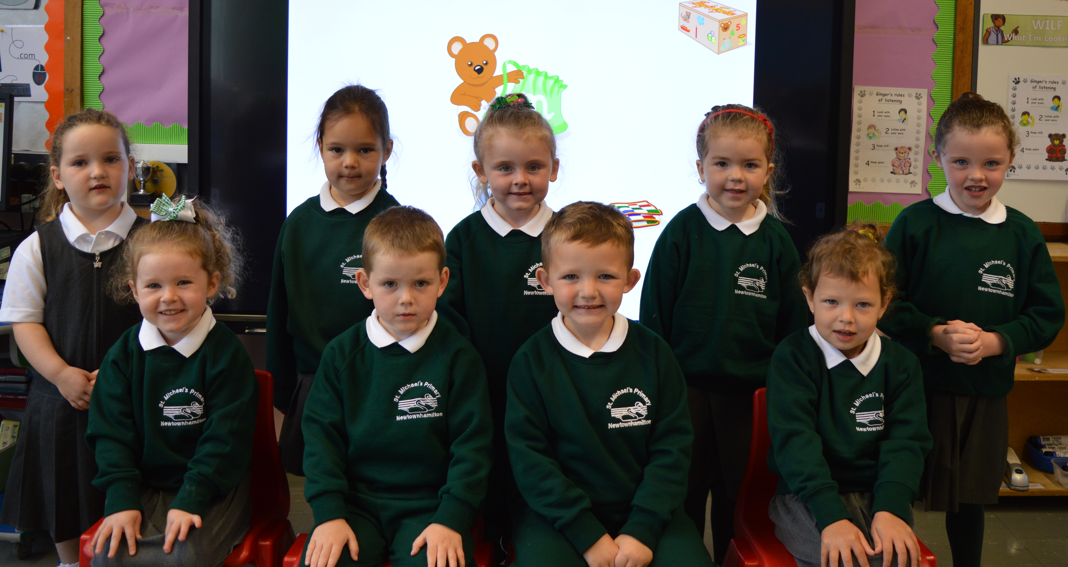
Welcome:
I would like to take this opportunity to welcome back all of our pupils and their families to St Michael’s PS. It has been great to open our doors again and do what we do best- teach the wonderful children of Newtownhamilton! I especially welcome all nine of our new Primary 1’s and any new families to our school.

Holidays:
School holidays for the year are now on the school website – www.stmichaelsps.co.uk, saved in the Parent Area. We would encourage that family holidays are taken when school is off! Holidays for this year have changed from originally planned- we have tried to ensure, as much as possible, uniformity with standard holidays for post-primary schools.
Staff:
Teaching staff are as follows:
P 1/2 Ms J Quinn and Mrs A Cumiskey (Mrs Cumiskey on Mon/Tues)
P 3/4 Ms Mc Keever
P 5/6 Ms E Carragher
P 6/7 Mr Murphy and Mrs Lavery (Mrs Lavery on Wednesday/Thursday)
Pupil Collection:
Primary 1 children go home at 12.30pm for first two weeks of September only. Then they finish at 2pm with the Primary 2’s for the remainder of the year. Primary 3 children go home at 3pm, except on a Friday which is @2pm.
Please remember, P1-3 children must be collected by an adult (over 16years) and are not permitted to walk home unaccompanied.
Milk:
If you would like your child to have milk at break time, or for their lunch, please complete the reply slip. Those who are having dinner in school are given milk or water to drink. Those pupils who had milk last year have £9 credit due to school closure.
Breakfast club:
Normally we would have Breakfast Club available for families from 8.15 to 9am at a cost of 50p per child, this initiative is largely funded through our Extended Schools budget and costs the school on average £3000 per year. They are provided with a drink (juice, water or milk), choice of cereal and toast or pancake. We would like to establish if there is a need for such a facility this year. If so, places would need to be booked in advance and taken regularly each week. Please complete the expression of interest form attached.
P1/2 After School Club
If there is enough interest, we hope to run our P1/2 Afterschool Club from 14th September. This will cost £1 per day and numbers will be limited- places will be allocated to working parents and families with older siblings in the school first.
PE:
On PE / coaching days, Primary 1 – 7 to wear their PE uniform. Please see the Calendar section on the school website to see when your child has PE (this will be updated over the next few weeks).
We are delighted to have Kevin Curran as our GAA coach- he will be with us every Friday and will coach all year groups, P1-7.
Soccer Club:
Soccer begins on Thursday 17th September for all P3-7’s and will run for 12 weeks. Primary 3/4 and 5/6 will take place during school hours from 1.30-3pm and Primary 6/7(Mr Murphy’s class) will take place after school from 3-4pm. This is funded through extended schools. Children from P6/7 wishing to take part should complete the attached reply slip to stay after school for the club.
Pictures / PR:
We will continue to promote our school through our website and local media. If you would not like your child to appear on the school website or in local press, please let the school know ASAP. (Please note – school website security does not allow images / clips to be copied from the site.)
Confirmation/Holy Communion:
Confirmation will be held on Saturday 19th September in St Michael’s Church @11am. There is a limit of 4 attendees per family (child +3). A practice will be held on Tuesday 15th September from 7-7.45pm for children only.
First Holy Communion date is set for Saturday 17th October at 11am in St Michael’s Church, Newtownhamilton.
Data Sheet:
A copy of the information we have for your family ie: names, address, contact phone numbers has also been sent home with the oldest child. Please make any amendments and return to the office. If all information is correct please write- No Change and return also. It is very important we have 3 contact numbers for each family.

Other Information:
- Classes begin at 9:15am but children can arrive to school from 9am- doors won’t open until 9am. Late arrivals can be disruptive so please ensure your child is on time. Late arrivals will have to buzz in at the main door, as for child protection reasons, doors are locked when classes start.
- At St. Michael’s PS we expect a high standard of good behaviour and to encourage this, the school has a positive approach to discipline. Our positive approach ensures that children know and accept our behaviour code which is:
In St. Michael’s we always;
- Do our best.
- Treat others with respect and kindness.
- Act safely.
- Care for our school.
- Show good manners.
If any parent requires a copy of our Positive Discipline policy or any other policy, these are available on request. (A selection of policies are available on the school website).
- SCHOOL DINNERS ARE NOW PRICED AT £2.60 EACH. (£13 PER WEEK) Please ensure dinner money is paid in full on a Monday for the week in advance. Menu is available on our website. Money should be placed in an envelope and clearly marked with name, total and purpose.
- Uniform in St. Michael’s is compulsory and we will insist on this throughout the year. Please label all uniforms as jumpers etc are frequently misplaced. If you have any unwanted uniforms that would suit P3, 4 or 5 please donate to school.
- Attendance in St. Michael’s is computerised and closely monitored by an outside attendance officer. Any absence should be reported in advance or on the day by phone or message with sibling. Absences with no note or message will be recorded as unauthorised.
- Our school operates a healthy break policy so fizzy drinks, crisps, chocolate bars etc are not permitted at break. We encourage all children to take a piece of fruit, prepared vegetable, bread stick or healthy sandwich each day to have at break time. It is very important that all children have water with them to school to keep themselves hydrated (only natural water- not fizzy or flavoured).
Contents of children’s lunchboxes are at the discretion of parents.
- If you have a concern about your child throughout the course of the year, we are always willing to discuss this. Please phone the school and I will return your call as soon as possible.
- Medical needs: please inform the office of any new medical needs your child may have.

C Murphy
Principal

Please have replies in for Tuesday 1st September
Breakfast Club @50p per day per child (8.15 – 9am)
I would like to register my interest for Breakfast Club:

Pupil(s) names : ______________________________________________
Please tick which days:
Monday ____
Tuesday ____
Wednesday ____
Thursday ____
Friday ____

Signed: _________________________

P1/2 Afterschool Club @£1 per day (2-3pm Monday to Thursday)
I would like to register my interest for P1/2 Afterschool Club:

Pupil Name: ___________________________

Signed: ___________________________

Milk
I would like my child(ren) to have milk every day @ a cost of £15 per child for the whole term. Starting Monday 7th September.

Pupil(s) names: _________________________________________

I would like them to receive milk at:
Please tick
Break time ____
Lunch time ____

Signed: ________________________

P6/7 After school Soccer Club
I give permission for my child _________________________ to attend after school Soccer Club on Thursdays from 3-4pm.
Signed: _______________________

