P7 Drive-by Graduation
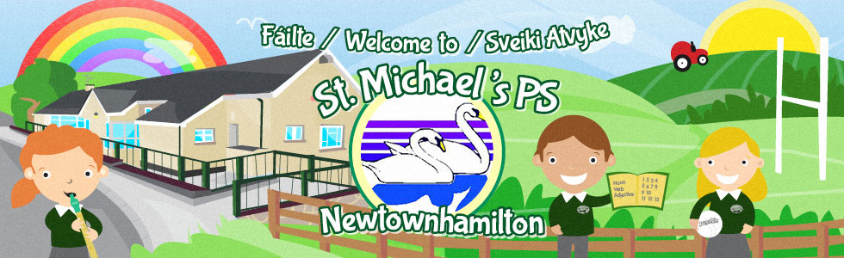
Friday 19th June 2020
Come along between 5-7pm

Have a catch up with your classmates and ‘old’ teachers (with social distancing!!)
Get one last photo outside the school
Special gift for all P7 leavers

